Request Canvas Shell
In this instructional guide, users will learn how to create a Canvas Course Shell for multiple sections in ONE.UF.
Table of Contents
Request Canvas Shell 1
Navigation 2
Accessing Canvas Shell Request 2
How to Exclude Sections from Canvas 6
Additional Help 7

Navigation
- Use the following to navigate to one.uf.edu in your web browser.
- Click LOG IN.
- Click Log in with Gatorlink.
- Enter your Gatorlink Username and Password.

Accessing Canvas Shell Request
- Select Go to Canvas Shell.
Note: If the Course Shell Request Card is missing, access the tool via this link: Canvas Course Shell Request - ONE.UF
- Select Term.
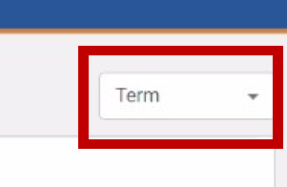
- Choose the correct term (for example, Summer 2021 will be used).
- Next choose Create a Canvas Shell Request.
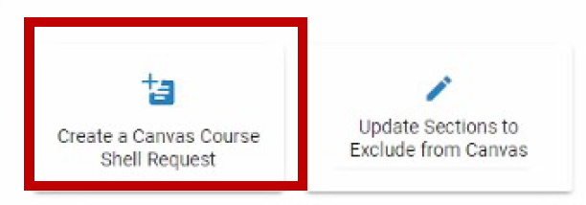
- Users have the option to select all sections or individual sections at one time. Click NEXT after the selection has been chosen.
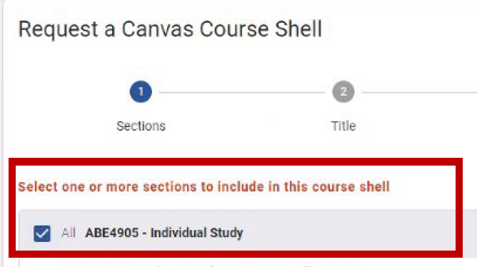
- Give the course a title. Click NEXT.
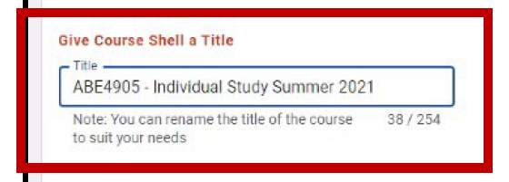
- Add additional people to the site by clicking +Person.
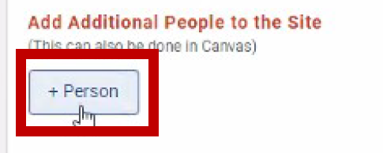
- Find the person by using the Gatorlink ID.
- After you find the person, assign the role.
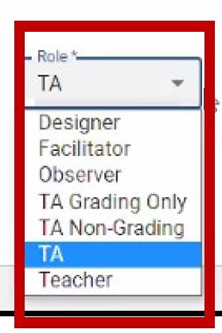
- Next, assign the section. You can choose all or just one section. Select NEXT.
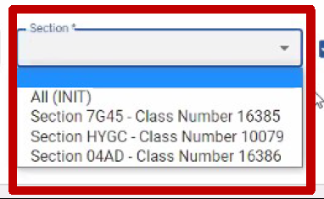
- Review your Canvas Course Shell and click SUBMIT.
- Choose Back to Summer 2021.
- The update may take up to 30 minutes.

How to Exclude Sections from Canvas
- Choose Update Sections to Exclude from Canvas.
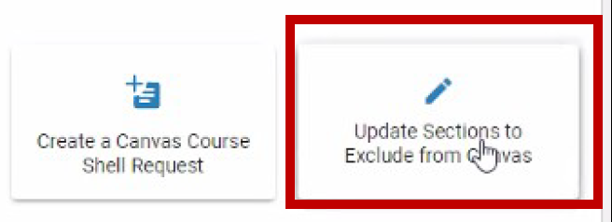
- Choose all sections or just one to exclude. For this example, one will be shown.
- Select Exclude: Section HYGA Class Number 10080, then select Save.
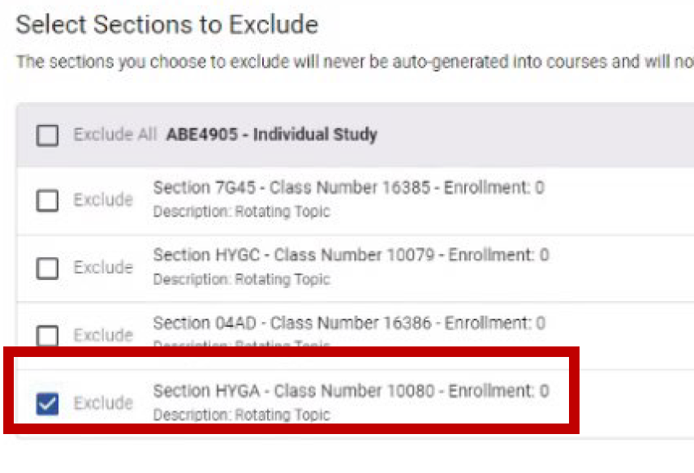
- Eligible and excluded sections are shown.

Additional Help
For help with technical issues, contact the UF Computing Help Desk at 352-392-HELP or helpdesk@ufl.edu.
For assistance with processes or policies related to Service Indicators, contact the Office of the University Registrar, 352-392-1374 or registrar.ufl.edu.

